# Exercise: Working with ASP.NET MVC

The purpose of this exercise is to make you **familiar** with Spring Boot MVC. After completing it, you should be able to **create a simple web application**.

This lab is part of the [“Software Technologies” course @ SoftUni](https://softuni.bg/courses/software-technologies).

# Part I: To Do List

If you successfully complete all steps you will have “To Do List” application with the following functionality:

* **Add Item** – adds an item to the list. It should look like this:

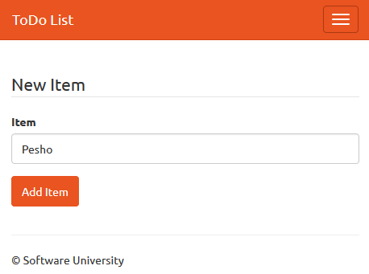 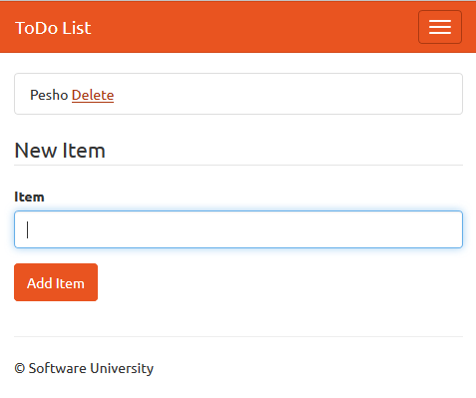

* **Remove Item** – removes the item from the list. It should look like this:

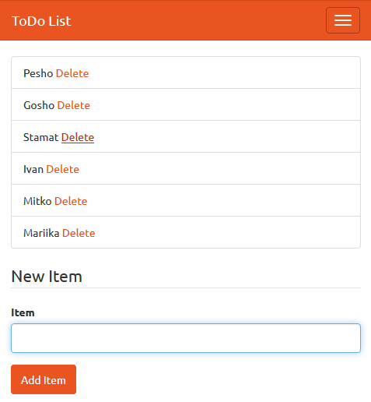 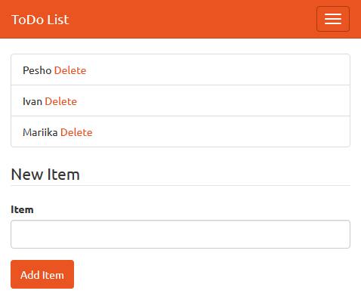

It should also keep your data if you exit the site (not the browser) and come back later.

## Create New Project

Let’s create new Maven Project.

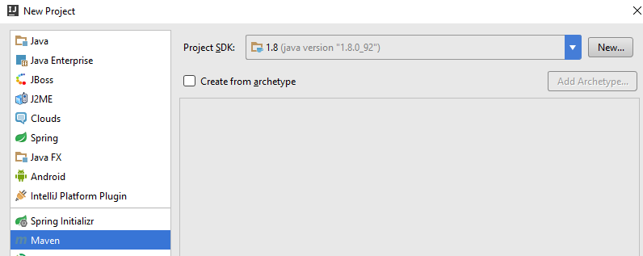

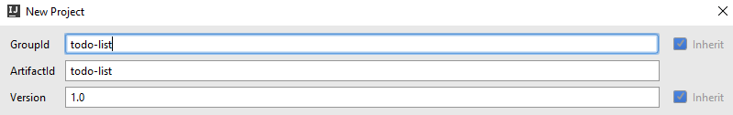

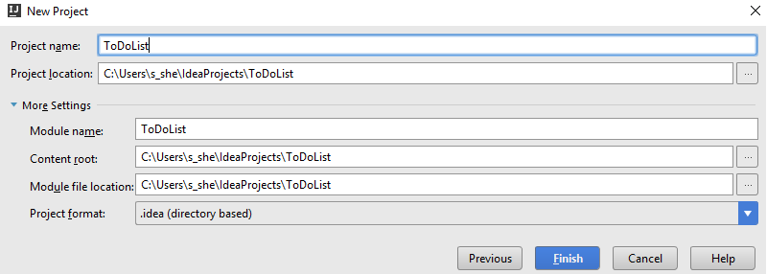

## Edit the Maven Configuration

We will edit our pom.xml now. Let’s write the following code:

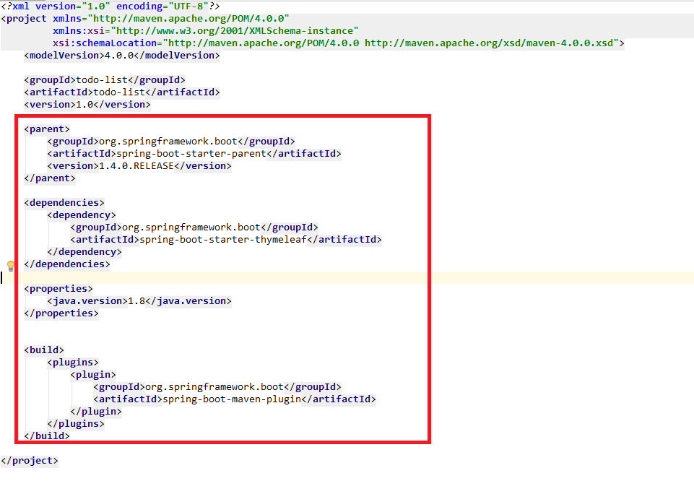

A little popup should appear, that is asking you to import maven projects. It is important to click “Enable Auto-Import”.

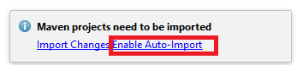

## Add bootstrap

Let’s create **new directory** in the “src/main/resources” folder:

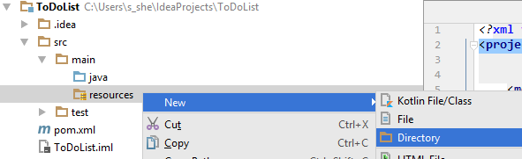

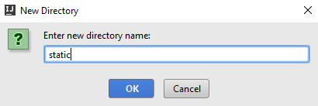

Call the directory “**static**”!

Inside the static directory, create new text file called empty:

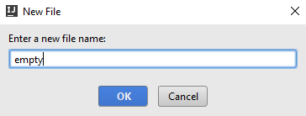

Now create another directory called “css” (in the static folder). Add your bootstrap file to that folder. You should have something like this:

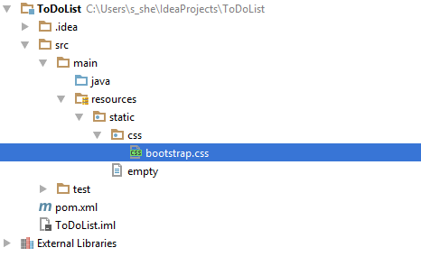

## Create the Class Structure

In your **java** folder, create a new **package**, called “app”.

In that package create a **new java class**, called Main. In that same package, **create another package** called “Controller”.

In that **Controller** package, **create a class** called “HomeController”. You should have this:

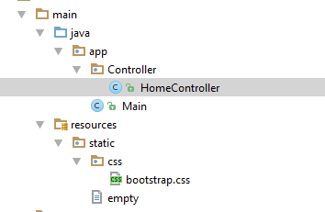

## Edit the Main Class

In your Main class, write the following code:

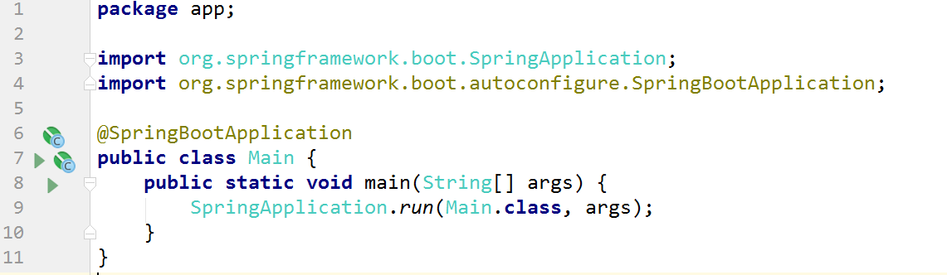

That is the start point of your application.

## Edit the Controller

In your HomeController, create a new method like this:

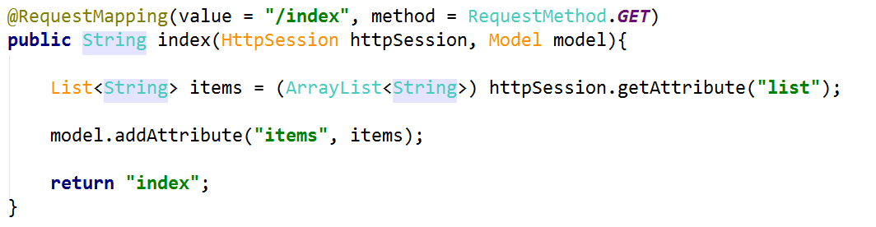

This will be our main page. We get the items from our session and pass them to the view. Before we are ready with this controller, we need to add a few methods. The first one will add elements to our list. You should create that method:

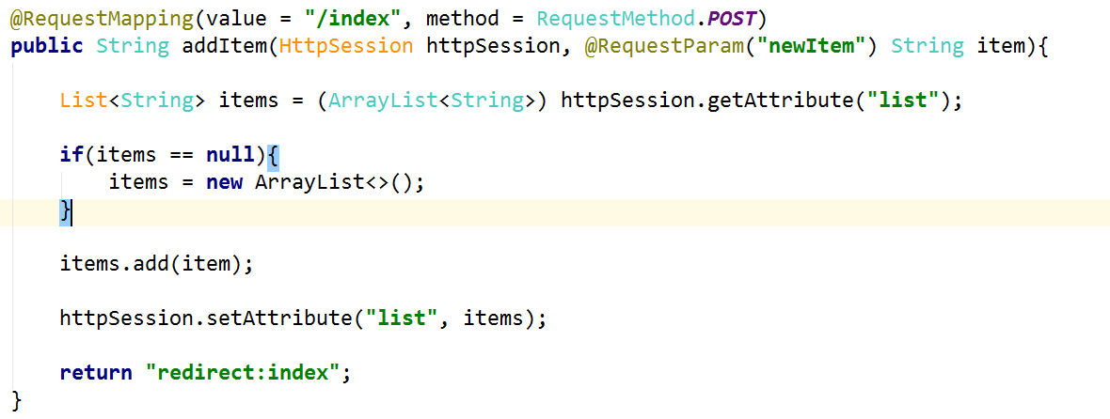

It adds new element to the list when a form is submitted in our view. Speaking of that view, let’s create it now.

## Create the View

Now we need to create a view. In the resources folder, **create a new directory** called “templates”. Now, create a new html file called “index.view”. You should have this:

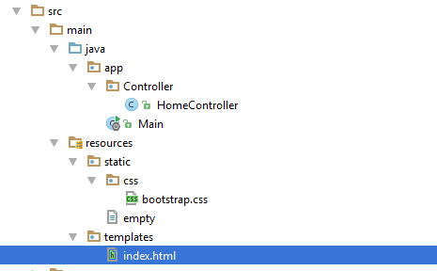

Because we are using Bootstrap, we will have a longer HTML code than we need to, but don’t worry. In our HEAD tag we will import the Bootstrap and give title to our app:

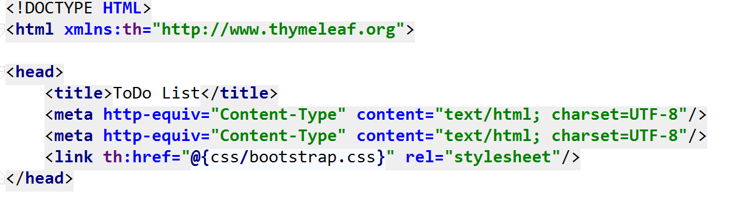

We will split our body into 2 parts. The first part will be our navigation menu:

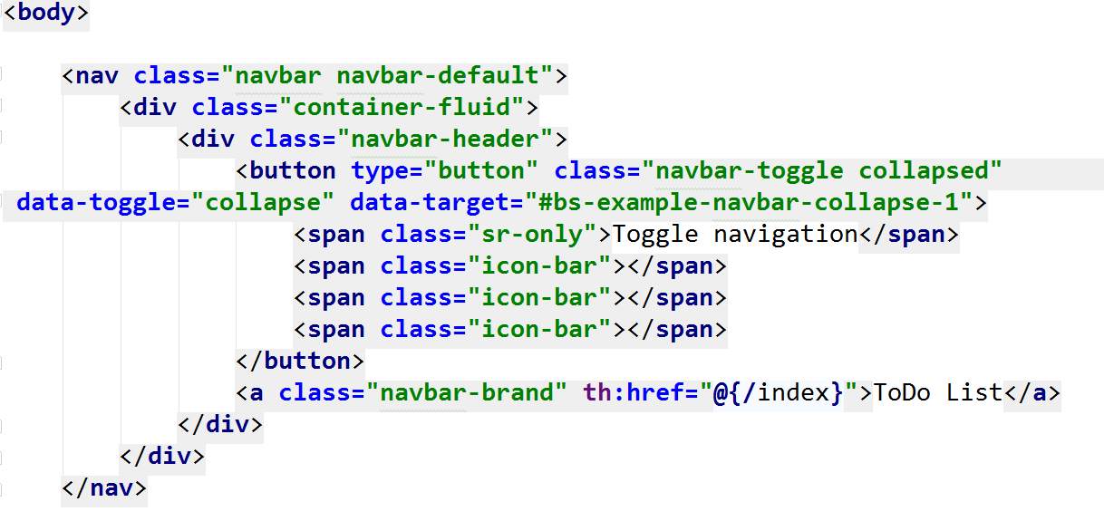

The second part is our actual content:

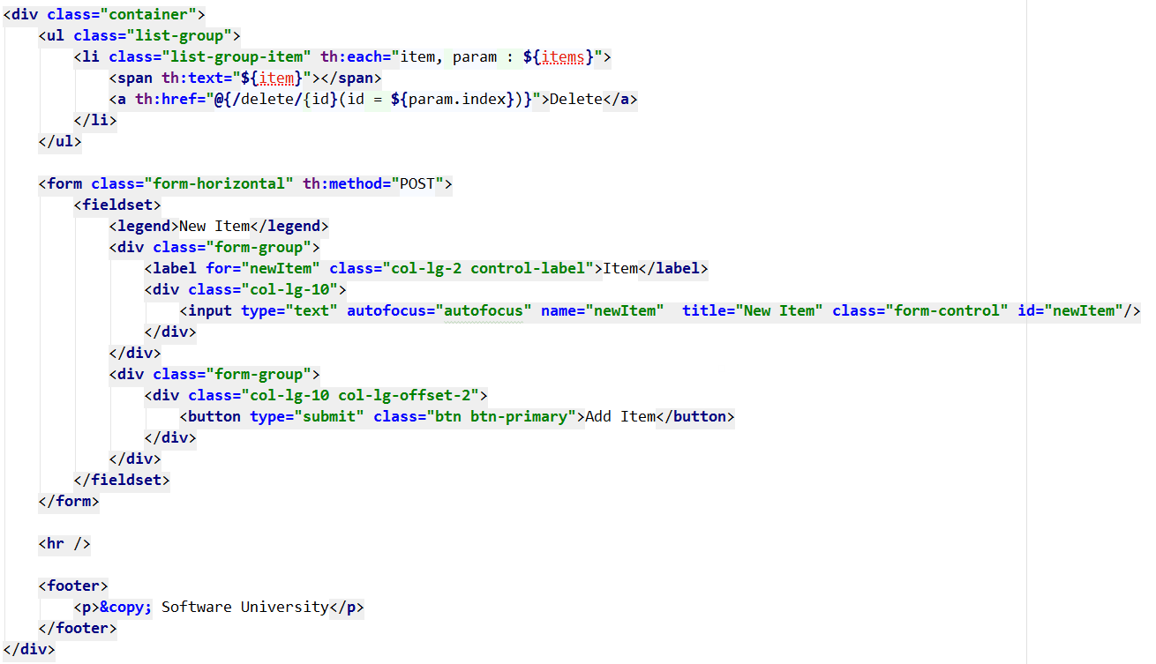

## Delete from the List

For our final part we only need to add one more method to our controller:

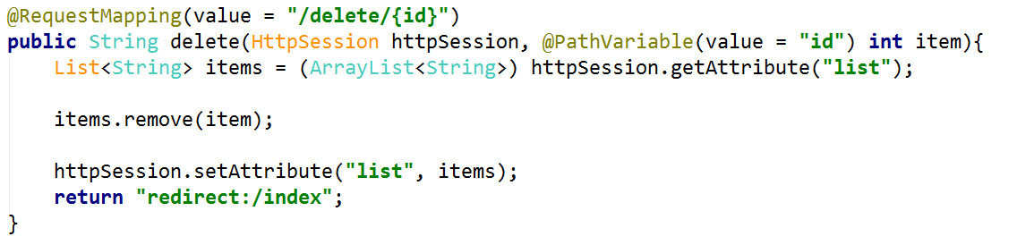

That is everything! Now you should fully functional application, like the one on the pictures in the beginning.